DATE : 23 March 2022
BY STUDENT PROMISE
Scheduled Date: 23/03/2022 ( TE ,BE Mechanical )
Topic : Webinar On Culture Clash : Hofstede Dimension
How To Prepare And Crack Manufacturing 4.0 Eco System
Session Expert : Mr Rohit Ghosh , CEO & Founder SKILLEDGE
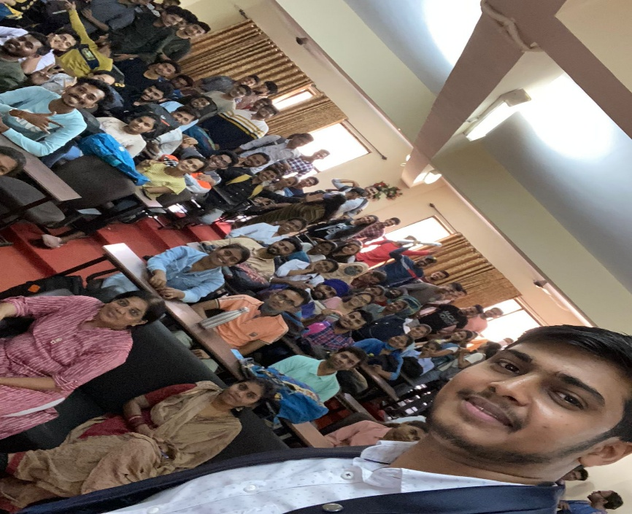
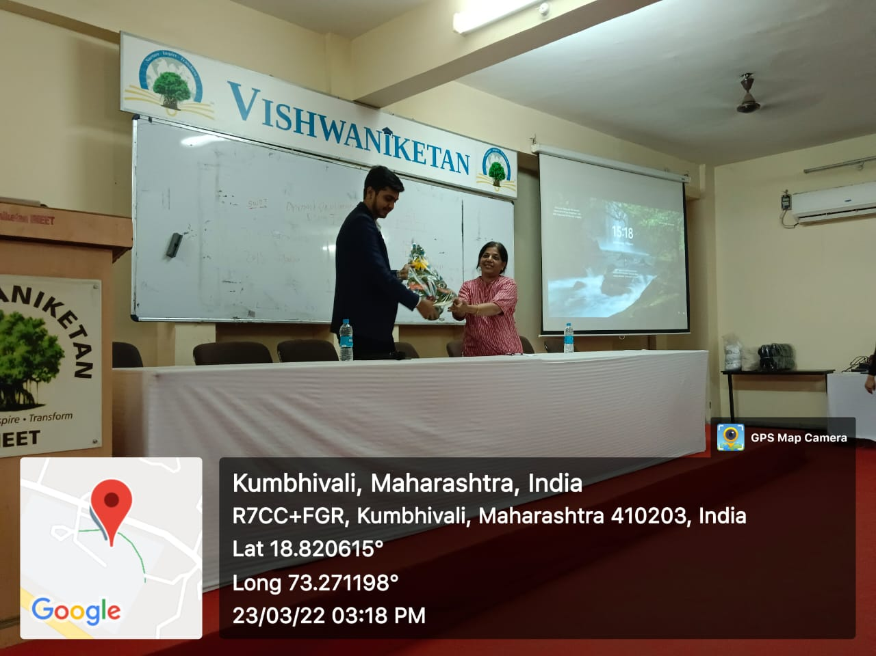
Total Number Of participants : 123

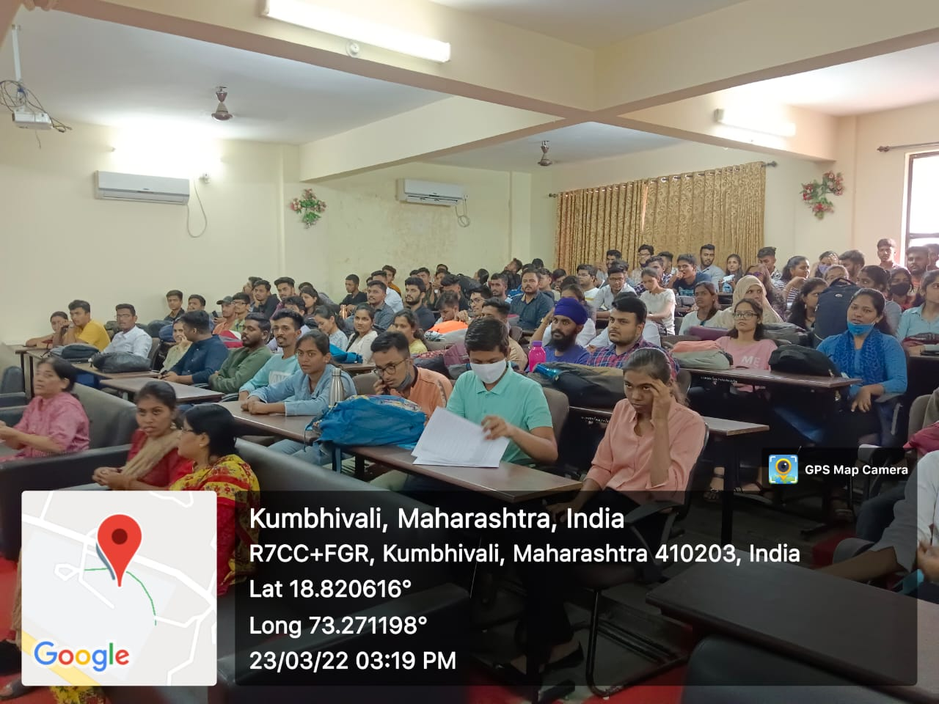
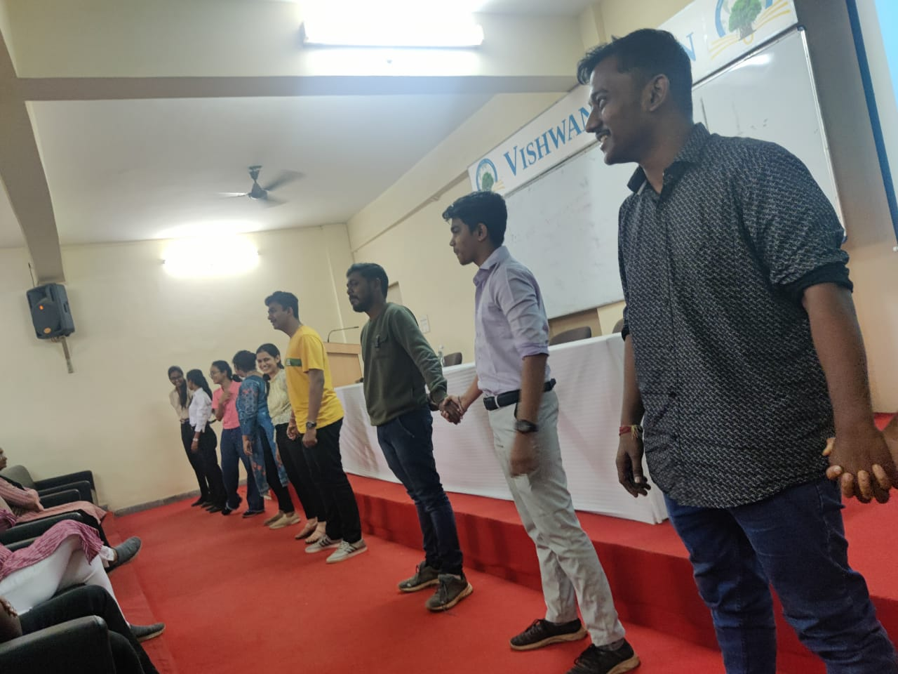

Prof Sunita Jadhav
Director I/C T & P

